PLANNING OVERVIEW 2019

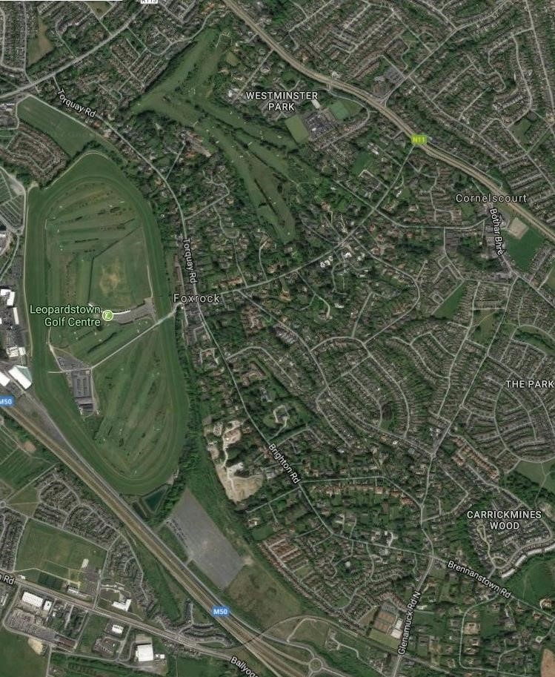

A Report by Feargall Kenny B.Arch., Dip. T.P., RIBA, MRIAI, MIPI

August 2018 (Updated January 2019)

BRIEF

I have been commissioned by Foxrock Area Conservation and Environment (F.A.C.E.) to examine the planning system as it operates in the Foxrock Architectural Conservation Area (ACA) as detailed in the current and previous County Development Plans, and in the areas immediately adjacent to the ACA.

F.A.C.E. is a company limited by guarantee, whose core mission is “To Enhance Foxrock as an Environment for our Community”. One of the objectives of the organization is to influence planning so as to preserve the distinctive character of the Foxrock Architectural Conservation Area.
F.A.C.E. represents residents and traders in an area roughly bounded by Leopardstown Road to the north, the line of the old Harcourt Street Railway to the west, Cornelscourt Hill and Claremount Road to the south and the N11 dual carriageway to the east, and which includes the townlands of Foxrock, Cornelscourt and Kerrymount as well as the village of Foxrock (Map 1). The objectives of the Company are the preservation, promotion and enhancement of the amenities of the area, and the promotion of positive and appropriate planning and development policies for the area.
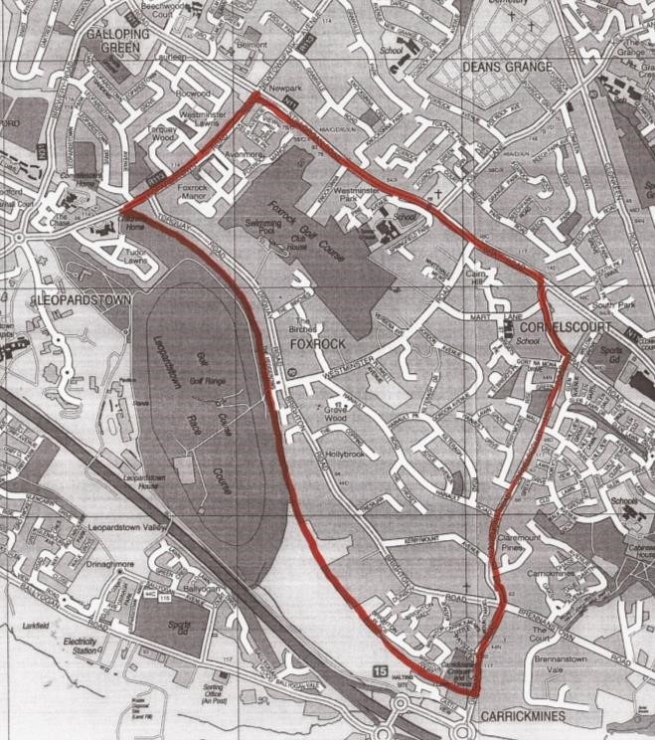

Map 1:
The Foxrock Area

F.A.C.E. is concerned with the operation of the ACA in the light of the on-going series of planning applications for development both within the ACA itself and on adjoining sites.

F.A.C.E considered that it would be useful to prepare a report covering the following points:

- History of planning decisions in the area prior to the adoption of the ACA as an objective in the County Development Plan
- Research into Planning applications and decisions within and adjoining the ACA from its inception to date.
- Comment on the reasons advanced by the planners for decisions within the ACA in the context of other possibly contradictory policy objectives of the Planning Authority. ▪ Conclusions and Recommendations

Before going on to examine the above matters it would be useful to provide some background material, including a short summary of the historical development of the suburb of Foxrock. It would also be helpful to summarise the current statutory planning legislation and how it impinges on the area.

HISTORY OF FOXROCK
The development of the suburb of Foxrock was initiated by William and John Bentley and Edward and Anthony Fox, who leased the lands of the Foxrock Estate from the Ecclestiacal Commissioners and Richard Whately, the Archbishop of Dublin in 1859. Their vision was to create a garden suburb of “beautiful building sites for mansions and pretty villas” as advertised in the Irish Times in 1862. In addition to creating an exclusive garden suburb within commuting distance of the city of Dublin, the intention was also to create “a pleasure ground and ornamental gardens” as noted in the Dublin Builder in 1862, making the area attractive as a holiday resort for Dubliners seeking “the fine air of a district midway between the mountains and the sea”. As can be seen from the map of the Parish of Kill (Map 2) the area was an unspoiled rural area at the time the Bentleys commenced the development of their grand dream.
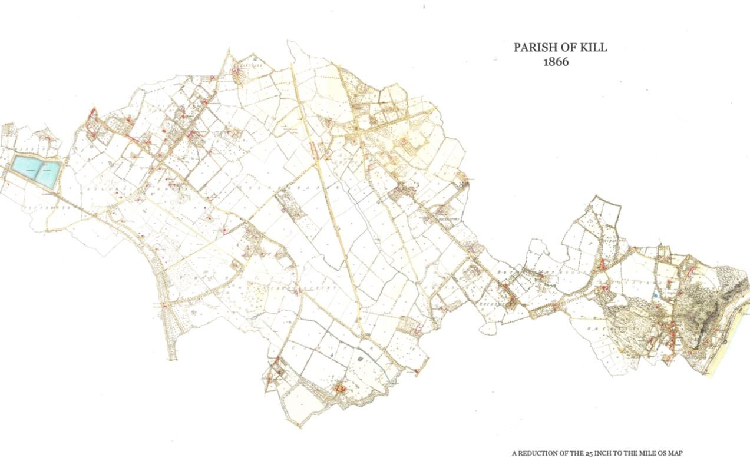

Map 2: The Parish of Kill 1866

With the arrival of the railway age and the construction of the Harcourt Street line between Dublin and Bray, William Bentley appreciated the facilitating of a railway link between Foxrock and Dublin City, and thus donated a site to the Dublin, Wicklow and Wexford Railway Company, where they constructed Foxrock Station, opened in 1861.

Significant development commenced in the area from the 1860s onwards, in which the primary roads associated with the heart of Foxrock were laid out. These included Leopardstown Road, Torquay Road, Brighton Road and Westminster Road. The Dublin Builder reported in 1861 that the area had attracted “several gentlemen to erect villa residences and elegant mansions….of a very superior character”. A number of villas are indicated on the 1871 OS map and include Hollybank House, Charlemont House, Mount Aventine, Kerrymount House and Tullow House on Brighton Road, Aille Meara, Whitehall, Stanford House and Hillside on Westminster Road and a number of structures on Torquay Road, including Woodbine Cottage and Foxrock Villa. Also indicated is Tullow Church on Brighton Road, built on a site donated by William Bentley and designed by Welland and Gillespie in 1864.

Leopardstown Racecourse and Foxrock Golf Club were established in the late nineteenth century to cater for the leisure pursuits of the well-heeled local residents. The area attracted many notable residents, including members of the Ascendency, professionals and businessmen from the city of Dublin, artists and literary figures. Many of the houses were designed by prominent architects of the day, including Richard Caulfield Orpen, Frederick Hicks, Richard Millar and W D Caroe. Orpen also designed St Brigid’s boys primary school on Mart Lane, which was opened in 1903.

The elegant villas represented some of the finest examples of Victorian and Edwardian domestic architecture and were set in well-tended spacious grounds with luxuriant planting, as befitted the affluence and status of their owners.

The 1910 Ordnance Survey map (Map 3 below) depicts a marked increase in plot divisions and development of houses along the principal roads. Also significant is the replacement of a large part of Victoria Road and The Birches by Foxrock Golf Club, and the appearance of Kilteragh and its gardens on the south side of Westminster Road. Development of the village is evident with Findlater’s grocery store, now known as the Gables, built in 1904 to a design by W A Kaye Parry, at the junction of Torquay, Brighton and Westminster Roads. Also included is the row of artisan’s cottages at Brighton Terrace.

Further development is noted on the 1940 OS map (Map 4 below), the most notable being the development of the land between Torquay Road and the railway line, and the new roads at Plunkett Avenue and Gordon Avenue. The plot sizes in these areas are significantly smaller than the primary plots in the earlier development phase.

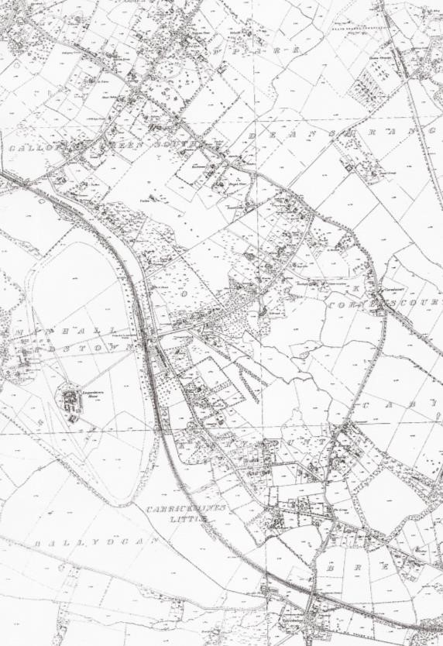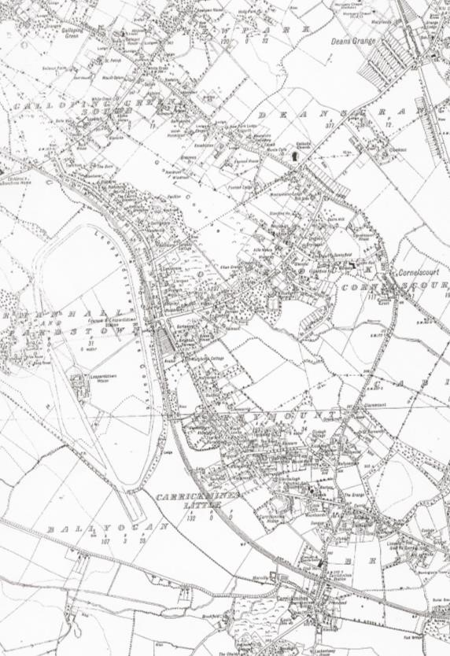

Map 3: Foxrock 1910 Map 4: Foxrock 1940

Development since the 1950s has included the loss of several large houses such as Rock House, Glensilla, Foxrock House, Avalon and their replacement with modern housing estates. Also evident is the development of new housing estates within the grounds associated with the larger houses such as Cairn Hill, Kerrymount, Carrickmines House and Kilteragh Pines. Finally there are a couple of contemporary trends that are worth commenting on. One is the increasing incidence of older houses being purchased and demolished to make room for a smarter more up-to-date residence. There have been several instances of this trend in recent times, particularly on the west side of Torquay Road. There is also the phenomenon of a smaller one-off house being built within the garden of a larger house. Quite often this is a “downsizer” for the owners of the large house, which has become too big for them as they get older and their families move on. These developments do not normally pose a threat to the amenities of the area. However it is the purchase of the larger properties for redevelopment as high-density apartments and houses that has given rise to concerns by F.A.C.E. and others in relation to the operation of the planning system in Foxrock, and which is the impetus for this report.

THE PLANNING LEGISLATION
The Local Government Planning and Development Act 1963 introduced for the first time a statutory planning system for the whole of the country. In its preamble it is described as “an Act to make provision, in the interests of the Common Good, for the proper planning and development of cities, towns and other areas, whether urban or rural (including the preservation and improvement of amenities thereof)….” The Act came into for on October 1st 1964 and established Local Authorities as the Planning Authorities in their areas with the power to promote and control development.

The 1963 Planning Act was backed up by a number of statutory regulations and was supplemented by a series of amending Acts brought in over the years. Eventually the 1963 Act was replaced by the Planning and Development Act 2000, which is the current base legislation, again subject to a number of amendments and supporting regulations.

THE DEVELOPMENT PLAN
Planning Authorities are responsible for the strategic planning of development in their administrative areas. The principal tool for carrying out this function is the Development Plan. Strategic planning involves the allocation of particular areas of land for future development in accordance with the use zoning objectives for the area, and the setting of objectives for the provision of infrastructure to facilitate such development. The legislation requires a planning authority to make a new Development Plan for their area every 6 years. Over the period covered by this review the County of Dun Laoghaire Rathdown has been covered by Development Plans dated 1998-2004, 2004-2010, 2010-2016 and currently 2016-2022.

CONTROL OF DEVELOPMENT
The other major function of Planning Authorities is the control of development, to ensure that it is carried out in compliance with the zoning and other objectives of the Development Plan. This is achieved by a statutory application process under which a developer applies to the planning authority for permission to carry out a particular development proposal. The Authority may decide to permit or refuse permission. If any party is aggrieved by the Authority’s decision they may appeal it to An Bord Pleanala, whose decision on the issue is generally final. Planning Authorities also have available to them a system of Enforcement, whereby they have powers to prosecute developers who fail to carry out development in accordance with the terms of the planning permission or developers who are carrying out development without permission.

CONSERVATION AREAS
When preparing the 1998 – 2004 Development Plan Dun Laoghaire Rathdown County Council had recognized that there were areas within their jurisdiction that had special qualities that deserved protection under the planning system. However the legislative concept of the Architectural Conservation area did not exist prior to the adoption of the 2000 Planning and Development Act. Accordingly in the 1998 Development Plan the Council brought in the concept of labeling specific areas as “Conservation Areas” in the Development Plan. Several areas of architectural or historic interest in areas such as Monkstown, Dalkey and Glenageary were so designated. Foxrock was not included. The Council policy in relation to Conservation Areas was stated in the Development Plan as follows:
“Within a Conservation Area the Council will have particular regard to the impact of a proposed development on the character of the area in which it is to be placed. The preservation of the existing character of an area does not preclude all forms of development. All proposals for new development should preserve or enhance the character and quality of the environment within a Conservation Area.”

With the onset of the “Celtic Tiger” Foxrock came under increasing pressure from Developers. The planning permission granted in 2001 and subsequent development of the apartments at “Hollybrook” on Brighton Road (see below) alarmed local residents and as a result an association of residents and traders, Foxrock Area Development Ltd. (FADL), the predecessor to F.A.C.E., was established in 2002. Initially FADL lobbied for the Foxrock area to be designated in the 2004-2010 Development Plan as a Conservation Area and succeeded in having a large part of the area so designated. In the next few years development pressure increased and FADL, while not opposed to development per se, opposed the granting of planning permission for several major development proposals in the area, including Grove House on Hainault Road, Gortanore on Brighton Road; and Clonbur on Torquay Road, all of which are detailed below.

ARCHITECTURAL CONSERVATION AREAS
The Planning and Development Act 2000, was enacted subsequent to the adoption of the 1998 County Development Plan. For the first time the Act gave legislative force to the concept of Architectural Conservation Areas (ACAs) and Areas of Special Planning Control.

Section 81 0f the 2000 Act allows for a Development Plan “to include an objective to preserve the character of a place, area, group of structures or townscape… that is of special architectural, historical, archaeological, artistic, cultural, scientific, social or technical interest or…..value, or contributes to the appreciation of Protected Structures..….if the planning authority is of the opinion that its inclusion is necessary for the preservation of the character of the place….and any such place shall be referred to as an Architectural Conservation Area” Section 82 then goes on to stipulate that “In considering an application for permission for development in relation to land situated in an architectural conservation area, a planning authority, or the Board on appeal, shall take into account the material effect
(if any) that the proposed development would be likely to have on the character of the architectural conservation area.”

In fighting the various development proposals referred to above, it became clear to FADL that the designation of an area as a “Conservation Area” was merely aspirational and had no statutory backing. On the other hand it was seen that the designation of an area as an “Architectural Conservation Area” (ACA) as defined in Section 81 of the 2000 Planning and Development Act would have statutory backing and consequently would give planning authorities much more clout in terms of control of potential development in the designated area. As a result of this thinking several of the former Conservation Areas in Dun Laoghaire Rathdown County were redesignated as ACAs in the 2004-2010 Development Plan. In the written statement of the Plan Council policy in relation to ACAs was stated as follows:
“It is the policy of the Council to protect the special character of places, areas, groups of structures or townscapes within the County that,
- have special architectural, historical, archaeological, artistic, cultural, scientific, social or technical interest or value, or
- that contributes to the appreciation of protected structures, by the introduction of Architectural Conservation Areas.
The purpose of an Architectural Conservation Area designation is to protect and enhance the special character of the A.C.A., and its objectives are to:
- Conserve, restore and rehabilitate the existing building stock in the area
- Ensure that all proposed developments are carried out in a manner sympathetic to the special character of the area.
The carrying out of works to the exterior of a structure in an Architectural Conservation Area shall be exempted development only if the works do not affect the character of the exterior of the structure or that of neighbouring structures”

The Council undertook to prioritise the designation of further ACAs within the lifetime of the development plan based on an assessment to be carried out of the character of existing Conservation Areas, including limited specified areas in Dalkey, Killiney and Foxrock.

The inclusion of Foxrock in the Policy statement came about as a result of persistent lobbying by FADL. Following the adoption of the 2004 Development Plan further pressure by FADL for Foxrock to be redesignated as an ACA resulted in the planning authority initiating a Conservation Area Character Appraisal of the area. The Report on the Character Appraisal recognized that the area has a distinctive character which is part of our architectural and social heritage and that the unique qualities of the area require special protection under the planning system. As a result the core area of Foxrock consisting of the houses and gardens along Torquay Road, Westminster Road, Brighton Road, Kerrymount Avenue and their immediate environments, was designated as an ACA in the lifetime of the 2004-2010 County Development Plan by means of a variation of the Plan (Variation no.9) enacted in July 2007. This designation has been carried forward into the current
Development Plan.

The Development Plan Policy in relation to ACAs (Par. 6.1.4.1 : Policy AR12) is stated as follows:
- Protect the character and special interest of an area which has been designated as an Architectural Conservation Area.
- Ensure that all development proposals within an ACA be appropriate to the character of the area having regard to the Character Appraisals for each area.
- Seek a high quality, sensitive design for any new development(s) that are complimentary and/or sympathetic to their context and scale, whilst simultaneously encouraging contemporary design.
- Seek the retention of all features that contribute to the character of an ACA including boundary walls, railings, soft landscaping, traditional paving and street furniture.

The protected status afforded by inclusion in an ACA only applies to the exteriors of structures and features of the streetscape. It does not prevent internal changes or rearrangements provided that these changes do not impact on the external appearance of the structure. While the purpose of ACA designation is to protect and enhance the special character of an area, it should not be viewed as a means of preventing new development but rather to help guide and manage change to ensure developments are sympathetic to the special character of the ACA.

Unfortunately the Council did not extend the ACA designation to the whole of the area which had been designated as a “Conservation Area” in previous development plans. In fact quite large areas including Hainault Road, Gordon Avenue, Mart Lane, Knocksinna and Foxrock Golf Club were excluded from the ACA. So also were the lands between the rear of the houses on Brighton Rod and Torquay Road and the old railway line. On Westminster Road itself the line was drawn very tightly on either side to exclude large undeveloped sites such as Weavers Hall and to the rear of Stanford House. Unfortunately also these areas (which made and continue to make a large contribution to the ambience of the ACA) were deprived of even the minimal protection offered by their “Conservation Area” status as this designation was discontinued from the 2010 Development
Plan onwards. The ACA as now designated in the Development Plan is shown below (Map no. 5)

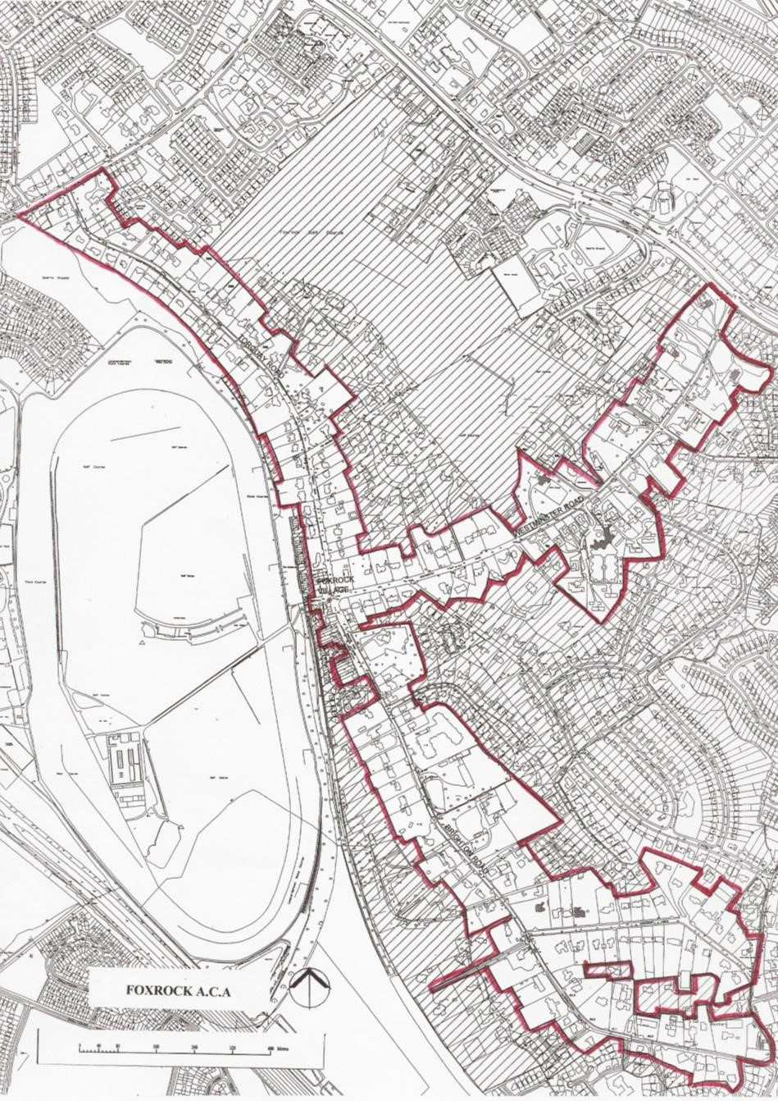

Map 5: The Foxrock ACA

FOXROCK ACA CHARACTER APPRAISAL
The Character appraisal carried out by the County Council prior to designating the Foxrock ACA summarised the architectural character of the area as follows:
“Foxrock is important both architecturally and historically and provides a social commentary on this part of Dun Laoghaire Rathdown over a 170-year period. Developed as a garden suburb in the mid-nineteenth century, the houses are principally residential dwellings of higher socio-economic type…..the architectural character of the area is created not just by the design of the individual structures. A significant aspect of its character is informed by the layout of sites, the settings of buildings within the sites and the surrounding landscaping. The overall visual character of the area is sylvan in nature characterised by low density residential development with well enclosed road corridors which are almost rural in character. The welldefined road edges are enclosed by mature planting and property boundaries which generally consist of a limited palette of natural materials including granite walls, timber and metal fencing and gates or hedging. In urban design terms this this type of development is described as ‘Arcadian’ a concept given its clearest formulation in the Essex Design Guide first published in 1953.”
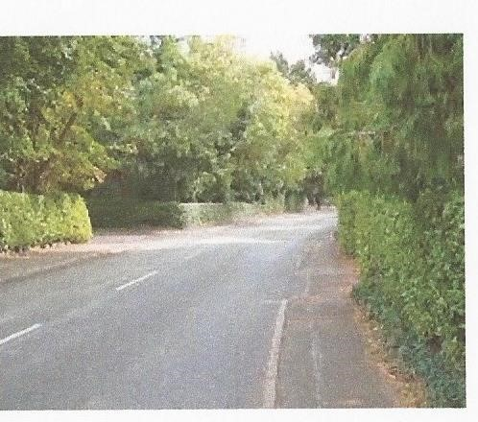

Fig. 1: Brighton Road. The essence of the Arcadian concept underlying the ACA designation

The essential feature of the Arcadian suburb is the use of landscape to enclose the buildings, creating the illusion of a rural environment in a residential area. The houses built as part of the original development of the Foxrock Estate are generally planned as substantial villas set in spacious grounds. Later houses were built in the Art & Crafts style. These are generally of a smaller scale representing a changing socio-economic profile and a reduction in the number of domestic staff employed by households.

ZONING
With the exception of the Golf Club lands (zoned for recreational open space) and a Neighbourhood Facility zoning covering the commercial properties in Foxrock Village, all of the lands in the Foxrock area, including both the ACA lands and the former Conservation Area lands are residentially zoned (Zone A) in the County Development Plan. Apart from its stated aim (“To protect and/or improve residential amenity”) this zoning objective also allows for residential development and redevelopment within the parameters of the various other objectives set out in the Development
Plan. Of these the most important is Density.

DENSITY
In many countries density standards, which specify the number of dwellings permitted in a particular area, are widely used to control residential development. Residential density standards are sometimes complemented by plot ratio, site coverage or height restrictions. Density is increasingly seen as tool in pursuit of principles of sustainability, the prevention of urban sprawl and the protection of greenfield land.

For successive Development Plans from 1963 to the turn of the century, the density of new housing developments on greenfield sites on the fringes of the suburban areas of South County Dublin was effectively capped at a maximum of 8 houses per acre (20 houses per hectare). A similar situation prevailed in respect of infill developments in existing built-up areas which were required to be compatible with the density of adjoining developments.

From 1990 onwards there was increasing concern that that this type of development was unsustainable. Together with prescriptive road design and open space standards these density restrictions reduced the efficiency of existing infrastructure and serviced land, did not assist in the promotion of a quality public transport systems and led to unsustainable commuting patterns.

Changing Government policy was reflected in the policy document “Sustainable Development – A strategy for Ireland” published in 1997. The policy advocated the promotion of higher residential densities to play an important part in ensuring that the best use is made of land intended for development. In 1999 the Government published “Guidelines for Planning Authorities on Residential Density”. The Guidelines articulated Government Policy of “encouraging more sustainable urban development through the avoidance of excessive suburbanization and promotion of higher residential densities in appropriate locations, especially in conjunction with improved public transport systems”.

This was followed by further Government publications “Quality Housing for Sustainable Communities Guidelines” in 2007 and “Sustainable Residential Development in Urban Areas - Guidelines for Planning Authorities” in 2009. Both of these publications further stressed the need for planning authorities to maximize the use of zoned and serviced residential land. Consolidation through sustainable higher densities was encouraged so as to allow for a more compact urban form that would more readily support an integrated public transport system.

Dun Laoghaire Rathdown County Council has taken these recommendations on board in the current and previous Development Plans. The council seeks to maximize the use of zoned and serviced residential land by consolidation through sustainable higher densities, including additional infill accommodation in established residential areas. The Development Plan states that this has the potential to reduce the urban and carbon footprint of the County.

In the current 2016 – 2022 Development Plan, the Council policy in relation to Residential Density is to promote higher residential densities provided that proposals ensure a balance between the reasonable protection of existing residential amenities and the established character of areas, with the need to provide for sustainable residential development. The Development Plan quotes the Guideline recommendations regarding appropriate densities for various types of locations. Where a site is located within circa 1 kilometre pedestrian catchment of a rail station, Luas line, Quality Bus Corridor and/or 500 metres of a Bus Priority Route, and/or 1 kilometre of a Town or District Centre, higher densities at a minimum of 50 units per hectare will be encouraged. Furthermore it stipulates that “As a general rule the minimum default density for new residential developments in the County shall be 35 units per hectare”. They concede that this density may not be appropriate in all instances, but will serve as a general guidance rule.

They also state that in some circumstances higher residential density development may be constrained by Architectural Conservation Areas (ACA) “To enhance and protect ACA’s, new residential development will be required to minimize any adverse effect in terms of height, scale, massing and proximity”.

PLANNING CONTROL IN FOXROCK
The operation of planning control in relation to major developments in the Foxrock area since the turn of the present century falls into three main periods;

2000 – 2008 The “Celtic Tiger” Years
2008 – 2013 Recession
2013 – to date Renewed development pressure

As a result of its overwhelmingly residential character, the vast majority of the lands in the Foxrock area are covered by zoning objective A ‘to protect and/or improve residential amenity’ in the Development Plan. It is also a very low-density area compared to other Dublin suburbs. Because of this and because of its perceived cachet as a desirable place to live, most planning applications in the area are for residential development. The zoning category is fairly narrow, with only Residential, Residential Institution (which includes Nursing Homes), Travellers Accommodation, Open Space and Public Services being permitted in principle. A number of other uses such as Doctor/Dentist etc., Education, Embassy, Garden Centre/Plant Nursery, Guest House, Hotel/Motel and Neighbourhood shop are open for consideration but may only be permitted where the Planning Authority is satisfied that the proposed development would be compatible with the overall policies and objectives for the zone, would not have undesirable effects, and would otherwise be consistent with the proper planning and sustainable development of the area.

An amount of suburban-type residential development has taken place in and around Foxrock from the 1960s onwards right up into the period under review. In general these developments would be regarded as typical suburban medium density low-rise. Examples include:
- Developments off Hainault Road including Kilteragh Road, Joyce Avenue and The Thicket.
- Foxrock Manor and Avonmore on the grounds of Glensilla on Leopardstown Road.
- Various cul-de-sac developments off Brighton Road, including The Coppins, Avalon, Tresillian, Brighton Avenue, Brighton Hall, Dunboy and Mount Sandel.
- Cairn Hill and Kilteragh Pines on Westminster Road.
- The Birches off Torquay Road
- The Hedgerows in Foxrock village
However from about the year 2000, encouraged by changing official attitudes on sustainability, growing prosperity and the prospect of cashing in on the Foxrock name by getting more homes per acre, developers increasingly homed in on the large sites in the area and put forward proposals for higher density developments including apartments in blocks of three and more storeys, as well as three-storey town-houses and duplexes. Most of these were located in or immediately adjacent to the ACA and have given rise to considerable local opposition. Examples from each of the last two decades are set out below.

A. MAJOR PLANNING DECISIONS & DEVELOPMENTS 1998 – 2008

KELSTON AND SEFTON HALL, LEOPARDSTOWN ROAD: The development on this site was granted permission by An Bord Pleanala in August 1998 and in many ways set the stage for future residential developments in the area. The development consisted of 85 dwelling units (7 detached houses, 39 2-storey terraced houses and 39 apartments in 4-storey blocks) on a site of 3.16 hectares. A 51 bed nursing home was also included and Kelston House was to be sub-divided into 3 further apartments in a subsequent application. Not including the Nursing Home the density of development was to be 28 units per hectare.

HOLLYBROOK, BRIGHTON ROAD: Over a period of two years (1999 – 2001) two separate planning applications were made in respect of this site. The first application in 1999 was for the demolition of the existing house and the construction of 44 apartments in a part three, part four-storey building over basement car-parking, on a site of 1.24 ha at a density of 35.5 dwellings per hectare (dph). The application was refused planning permission by the County Council in September 2000. There were 3 reasons for refusal, one of which noted that the site was located in an area of special amenity value characterised by low density and low to medium density residential developments. It was considered that the proposed development by reason of its excessive bulk and density, would seriously injure the special amenities of the area and would set an undesirable precedent for further such developments in the area. Another reason for refusal highlighted issues of proximity and overlooking of adjoining dwellings by virtue of which the proposal would be seriously injurious to the residential amenities and depreciate the value of property in the vicinity and would be contrary to the proper planning and development of the area.

The applicant appealed this decision to Bord Pleanala, which in turn refused permission in March 2000. One reason for the refusal was given. This related to the height of the proposed building and the inadequate separation distances from the adjoining boundaries which would result in overlooking of the adjoining properties with consequent loss of privacy. The proposed development would therefore seriously injure the amenities of the adjoining properties and be contrary to the proper planning and development of the area.

Following these refusals the developer came back with a new application for a similar development. In this case the number of apartments was reduced to 42. The application took note of Bord Pleanala’s reason for refusal and made appropriate adjustments to the layout. Otherwise the proposal was broadly similar to the previous application with a reduced density of 34dph. This application was also refused by the planning authority in September 2000 on grounds similar to the previous refusal. It also referenced the poor public transport availability in the area.

Once again the applicant appealed this decision to An Bord Pleanala, who reversed their previous position and decided to grant planning permission for the proposal in February 2001. Their reason
was given as “Having regard to the residential zoning of the site and the Residential Density Guidelines for Planning
Authorities issued by the Department of the Environment and Local Government in September 1999, it is considered that……the proposed development would not seriously injure the amenities of the area or of property in the vicinity, would be acceptable in terms of traffic safety and convenience and would be in accordance with the proper planning and development of the area.”
It is clear that this reversal of the previous decision was influenced by changing official attitudes to density and sustainability. At the time of this decision the area had no special protection by way of Conservation Area or ACA designation.

GROVE HOUSE, HAINAULT ROAD: A planning application was made in 2002 for 71 units in a mixed development of houses and apartments in 4 buildings of 2 to 4 storeys, including conversion of the existing house. The site area was stated to be 1.24 ha, which gave a density of 57 dph. The proposal was refused permission by the planning authority for 4 reasons which included density, height, bulk, scale and high plot ratio of the proposal. The refusal stated that the proposal would represent an unsatisfactory standard of development in terms of design and layout, and would therefore be contrary to the proper planning and development of the area. Also due to its unsatisfactory design and layout the proposed development was considered to be out of character with the pattern of adjoining residential development and would seriously injure the amenities and depreciate the value of property in the vicinity. The proposed development would therefore contravene materially the zoning objective 'To protect and / or improve residential amenity'.

This application was withdrawn on appeal and a second application was made for the demolition of existing house and construction of 46 no. apartments in a 4 storey building with basement car parking and 8 3-storey townhouses. The density of the development was reduced to 43.5dph. This time the Planning authority made a decision to grant planning permission. In defence of this decision the planners report stated that “it is considered that the proposed development would not seriously injure the residential or visual amenities of the area and would not contravene materially the current Development Plan for the area. The proposed development would therefore, be in accordance with the proper planning and sustainable development of the area.”

This decision was appealed to An Bord Pleanala by a number of concerned local residents. The Bord overturned the Council’s decision and refused permission in November 2003. Three Reasons for refusal were given including “that the quality of design and layout would not justify the higher density proposed and fails to achieve an acceptable balance between the reasonable protection of amenities and privacy of adjoining dwellings, the protection of established character and the need to provide residential infill”. There was also an issue about the removal of mature trees from the site which would contravene materially a development objective in the Development Plan and would seriously injure the visual and residential amenities of property in the vicinity. And finally the Bord also held that “the proposed development, by reason of height, scale, form and bulk and by reason of proximity to the boundaries of adjoining properties, fails to respect the character of the neighbourhood and would seriously injure the amenities of the area and depreciate the value of property in the vicinity.”

A third application in early 2004 proposed the re-configuration of Grove House and construction of new 2 storey plus dormer level extension all to provide 8 no. apartments and 18 new houses at a very much reduced density of 14dph.

The planning authority decided to grant permission for this development subject to a number of standard conditions. The Planners report in this case noted that “Having regard to the current County
Development Plan, it is considered that subject to compliance with the conditions, the proposed development would not seriously injure the residential or visual amenities of the area and would not contravene materially the current Development Plan for the area. The proposed development would therefore, be in accordance with the proper planning and sustainable development of the area”. This decision was not appealed and the final grant of permission was issued in July 2004.

FORMER LORETO SCHOOL GROUNDS, SPRINGFIELD PARK: An application for the demolition of an existing house and the construction of 26 no. apartments in four blocks of two to five storeys with basement. car parking on a site of 0.25 ha at a density of 104 dph was refused by the planning authority in January 2008. Reasons for refusal included that “the design, scale, bulk and layout of the proposed development would be visually overbearing and out of character at this location and not a sufficiently high quality design solution for this prominent site, sub-standard open space provision would have an adverse impact on adjacent mature trees and thereby detract from the existing character and visual amenities of the area.”

This decision was appealed by the applicant but the refusal was endorsed by An Bord Pleanala for similar reasons. Subsequently a new application for the demolition of the existing house and the construction of 22 no. apartments in three blocks of three to four storeys with basement car parking was the subject of a decision to grant permission by the County Council in December 2009.
The Council reasoned that “Having regard to the County Development Plan, the proposed development would not detract from the amenity of the area and is consistent with the provisions of the current development plan and in accordance with the proper planning and sustainable development of the area.”

This decision was appealed to An Bord Pleanala by the applicant and by local residents. On 14.05.2010 the Bord granted permission for the development subject to a reduction of 2 apartments. The permitted 20 apartments are at a density of 80dph. The Bord’s reasoning for this decision was that “Having regard to the zoning objective for the area, and the “Sustainable Residential
Development in Urban Areas Guidelines for Planning Authorities” issued by the DoEHLG in 2009, inter alia and to the location of the site in proximity to a quality bus corridor, it is considered that, the proposed development would not seriously injure the visual or residential amenities of the area or of property in the vicinity and would therefore, be in accordance with the proper planning and sustainable development of the area.”

There is no record that the planning permission was extended beyond the usual 5 year term but the site was reportedly sold with planning permission in August 2018 for €3.6 million. However no development has commenced to date.

51 & 52 BRAY ROAD: This is a prominent site on the corner of Kill Lane and the N11 directly opposite Foxrock Church and across the main road from Springfield House. Permission was refused in October 2007 for the demolition of two dwellings and associated outbuildings and the construction of a 3 to 5 storey over part basement apartment building consisting of 38 apartment units, on a site of 0.358 ha (density 106dph). Reasons for refusal included excessive density, height, scale, design and massing on this prominent corner site, significant discordant visual impact on the existing character of the area and serious injury to the visual and residential amenities in the vicinity. Also would have an overbearing impact on adjoining properties and would result in overlooking of the adjoining properties with consequent loss of privacy and depreciation of the value of the property in the vicinity. The proposed development would therefore be contrary to the zonig objective and the proper planning and sustainable development of this area.

The above decision was not appealed. Instead a new application was made for planning permission for a reduced development consisting of the demolition of two existing dwellings and the construction of a two, three and four storey apartment building containing 30 residential apartment units and basement car park. (Density 78dph). In July 2008 the planning authority decided to grant planning permission for this proposal. This decision was appealed to An Bord Pleanala. However the Bord decided to uphold the decision of the Planning Authority and granted permission for the proposed development. The Bord’s reasons and considerations for this decision were stated as follows: “Having regard to the zoning objective for the area, as set out in the current Development
Plan for the area, the Dun Laoghaire Rathdown County Building Height Strategy (2007), the “Residential Density
Guidelines for Planning Authorities” issued by the Department of the Environment and Local Government in September, 1999, the “Sustainable Urban Housing: Design Standards for New Apartments Guidelines” issued by the Department of the Environment, Heritage and Local Government in September, 2007, and to the pattern of development in the area, it is considered that…. the proposed development would not seriously injure the visual or residential amenities of the area or of property in the vicinity and would be acceptable in terms of traffic safety and convenience. The proposed development would, therefore, be in accordance with the proper planning and sustainable development of the area”.

The planning permission was extended to February 2019 but no development took place. Instead a new application was made in January 2019 (See Page 27 below).

PORTUGUESE EMBASSY, KNOCKSINNA: A decision by the County Council in February 2007 to grant permission for 9 no. two-storey mews houses on a site of 0.22ha (density 41dph) to the rear of the Portuguese Embassy at Knocksinna House with access via Willow Grove, Westminster Park, was overturned by An Bord Pleanala on appeal. The reasons for refusal cited by the Bord included the restricted access from Willow Park , the loss of a mews building and courtyard which were an integral part of the setting of Knocksinna House, the adverse impact on the character of the conservation area in which the development was located, the adverse impact on the setting of a protected structure, and visual intrusion and overlooking of adjoining residences.

SPRINGFIELD HOUSE, SPRINGFIELD PARK: A planning application in 2007 for the demolition of Springfield House and no. 4 Springfield Park and construction of 23 no. apartments was refused by the planning authority and upheld on appeal by An Bord Pleanala for a number of reasons including the location of the site in relation to a Conservation Area, the height, massing and overly complex and horizontal design treatment of the proposed buildings; proximity to adjoining property; inconsistency with the character of the area; overbearing impact on and overlooking of adjoining property; and inadequate on-site car parking provision. Overall the Bord held that the proposed development would seriously injure the amenities of the area and of property in the vicinity

A new planning application in 2009 sought permission for the demolition of Springfield House and
No. 4 Springfield Park and the construction of 4 interconnected blocks, ranging in height from 2 to 4 storeys over basement car park, containing 19 apartments on a site of 0.285ha (density 67dpa). The County Council made a decision to grant permission in April 2009. However this decision was appealed to An Bord Pleanala by local residents and permission was refused by the Bord in December 2009 for similar reasons to the previous refusal, leading to the conclusion that “the proposed development would seriously injure the amenities of the area and of property in the vicinity and would, therefore, be contrary to the proper planning and sustainable development of the area”.

GORTANORE, BRIGHTON ROAD: This one of the most important sites in the Foxrock ACA. It has an area of 1.24 ha (3 acres approx. ). The site itself is located on Brighton Road immediately beside Thomas’ shop in Foxrock Village. The planners report notes that the site has a strong sylvan character with significant stands of mature trees informing all site boundaries and with an area of quite dense planting. It is a densely wooded site with a long tree-lined frontage to Brighton Road (See Fig. 2 below). In many ways this site represents the essence of the ACA. The existing house is not architecturally important, but it is all about the setting.

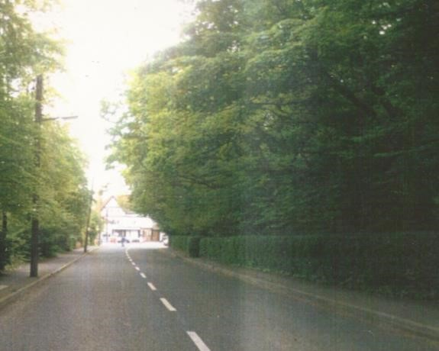

Fig. 2: Brighton Road looking towards “The Gables”. The road frontage on the right is “Gortanore”

A planning application was made in October 2007 for the demolition of the existing house and the construction of a mixed use development consisting of 37 apartments, ancillary gym/conference room and 279 sq m of retail space, in 3 blocks of 3 and 4 storeys over basement car-park (Density 30dph ±). After a request for further information the Planning Authority made a decision to grant planning permission in May 2008. There were a number of third party appeals against this decision. Acknowledging the importance of this site An Bord Plenala decided to hold an Oral Hearing of the appeals. In due course, notwithstanding the ACA designation and the arguments of the appellants the Bord decided to grant permission for the development in August 2009. The Bord’s reasons and considerations for its decision were that having regard to the residential zoning objective for the area in the County Development Plan, it was considered that, subject to compliance with the conditions, the proposed development would not seriously injure the amenities of the area or of property in the vicinity, or impact upon the designation of Foxrock Village as an Architectural Conservation Area and would be acceptable in terms of traffic safety and convenience. The proposed development would, therefore, be in accordance with the proper planning and sustainable development of the area.

Looked at objectively, in many ways this was not a bad development proposal for the area. There was to be a small addition to the retail space in the village, the residential blocks respected the sylvan nature of the site and the tree screen along the Brighton Road boundary, the blocks themselves were well designed and at 30dph the density would be quite acceptable in today’s climate. However by the time permission was achieved the recession had set in and in due course the permission lapsed. The site was subsequently sold to the Saudi Arabian Embassy for apparent use as a diplomatic residence. A planning application by the Embassy for the erection of a temporary chain-link fence behind the existing front boundary hedge was refused in February 2017 for being out-of-keeping with the character of Foxrock ACA. No further development proposals for the site have been submitted in the interim.

CLONBUR, TORQUAY ROAD
There were three planning applications for development on this site in the period 2000-2008. They were as follows:

- D03A/1070. This was an application for a single three-storey block of 9 town-houses, which was refused by the Council and not appealed. The reasons for refusal given by the Council included that the design of the 3-storey singular block including its scale, massing uninterrupted bulk and materials, represented an unsatisfactory standard of development in terms of design and layout, would be inappropriate and would adversely impact upon the residential character and form of houses in Foxrock Village.

- D04A/1463. Application for a single three-storey development of town-houses and apartments. Again it was refused by the Council for reasons which included that the proposed development was unacceptable by reason of its excessive scale and height, and the boundary treatment and the breaking of established building lines on Westminster Road and on Torquay Road on this “pivotal corner site”.

The decision to refuse planning permission was appealed to An Bord Pleanala by the applicant. The Bord endorsed the decision of the Planning Authority for the reason that
“Having regard to the location of the site at a corner adjacent to Foxrock village and within a Conservation Area, it is considered that the design and layout of the proposed development would be an inappropriate form of development at this location and would be detrimental to the character of the area. The proposed development would, therefore, contravene objective CA1 of the current Dun Laoghaire-Rathdown Development Plan which states that ‘within a Conservation Area the planning authority will have particular regard to the impact of a proposed development on the character of the area in which it is placed’. The proposed development would, therefore, be contrary to the proper planning and sustainable development of the area”.

- D08A/0166. This was an application for a mixed use development of 11 apartments with office and retail units in a three and four storey development. A decision by the Planning Authority to grant permission was appealed by third parties. The application was withdrawn and no further proposals were put forward until 2017.

B. MAJOR PLANNING DECISIONS & DEVELOPMENTS 2009– 2018

B.1 DEVELOPMENTS WITHIN THE ACA

“FOUR WINDS”, BRIGHTON ROAD
The Four Winds site is located within the ACA and is adjoined by two protected structures. There were a number of recent planning applications in respect of this property.

- D15A/0807: Application for demolition of existing house and construction of a three storey over basement 121 bedroom nursing home. In the course of the application the number of bedrooms was reduced to 113. There were numerous local objections but the Council made a decision to grant permission in March 2016. The Council Planner’s Report concluded that notwithstanding concern expressed by the Conservation Officer the proposed development is consistent with the zoning objective of the site and the Council’s Building Height Strategy. Therefore the development was considered to be in accordance with the proper planning and sustainable development of the area, and a decision was made to grant permission subject to conditions. The decision was appealed by third parties. However Bord Pleanala endorsed the decision to grant permission in September 2016, having concluded that the proposed development would not detract from the character of the Foxrock ACA, would not seriously injure the residential amenity of adjoining property or the visual amenity of the area, would not give rise to traffic hazard and would, therefore, be in accordance with the County Development Plan and with the proper planning and sustainable development of the area. Construction of this development was not proceeded with as it ws superseded by further planning applications for this site (see below).

Nursing Home use is a permitted use under the residential zoning for the area but obviously it cannot be assessed under the normal residential density rules. However building height, scale and massing would be measureable. Plot ratio and site coverage would be the usual tools used by planners for this purpose. The proposed building would have a plot ratio of 1.18 and a site coverage of 31.5%, which would be far in excess of the norm in the ACA. The height of the proposed flat roof building to parapet level will be 11.25m.

- D17A/0455: This was an application for demolition of the existing house and construction of an extended 140 bedroom Nursing Home and associated development. The site for this application extended into the adjoining residential site “Tall Trees” on Claremont Road. The Conservation Officer’s report on file states that

“I would be opposed to the proposed development as it is not considered to protect or enhance the special character of the ACA and is therefore contrary to Policy AR12 to ‘protect the character or special interest of places or areas which have been designated Architectural Conservation Areas…. New buildings within the ACA should be consistent with the scale, massing and height of neighbouring dwellings. It is considered that the scale, footprint and massing of the proposed three-storey over basement Nursing Home development is substantially larger in scale and massing than the immediate neighbours (both of which are Protected Structures). The development will result in the significant loss of trees which fails to respect the landscape character of Foxrock ACA which is informed by the layout of sites, the setting of buildings within the sites and the surrounding landscaping. The development does not reflect the existing pattern of development of the Foxrock ACA and is contrary to guidance for 'Infill Development and New Buildings' as set out in the Foxrock Character Appraisal”.

Despite the Conservation Officer’s report and despite numerous objections from concerned local residents the planning authority decided to grant permission for this extended proposal on in October 2017. A number of third party appeals were lodged against this decision. By order dated 16th July 2018 Bord Pleanala refused permission for the development. However the applicants sought a judicial review of the decision and it was subsequently quashed by High Court Order. The appeal was remitted back to An Bord Pleanala and after further consideration they granted permission by Order dated 30th October 2018.

- 17A/0742: This was probably a fall-back application in the event that permission was refused for the 140 bed proposal (B above). It involved modifications/improvements to the permitted 113 bedroom nursing home and extension into the adjoining site “Tall Trees”. Again despite numerous objections the planning authority decided to grant permission for this proposal in October 2017. Again there were a number of third party appeals against this decision but An Bord Plenala endorsed the Council’s decision to grant permission by order dated 13th March 2018.

Development of the site commenced in mid-2018 and construction of the Nursing Home is well advanced at time of writing (January 2019).

CASTLETHORN DEVELOPMENTS, BRIGHTON ROAD
2006 Application: This large development site incorporates substantial backlands to the rear of Brighton Road and mostly outside the ACA, but with some frontage on and with access from Brighton Road. There was an initial planning application in December 2006 for 49 detached houses on a site of approx. 5.24 hectares (Density 9.35 dph). In the course of seeking additional information the planning authority sought an intensification of the development. The revised plans submitted by the applicants further to this request allowed for 114 units, including a number of apartments at a density of 22dph. Following a number of local objections and clarification of the additional information requests the planning authority finally decided to grant planning permission for the proposal in July 2008.
This decision was appealed by several third parties to An Bord Pleanala who refused permission in May 2009 for a number of reasons including that by virtue of being situated within the Foxrock ACA, which is primarily characterised by detached dwellings on spacious plots in a sylvan landscape, that the proposed apartment buildings, by reason of their excessive scale and height, their monolithic form and incompatible design character, would be visually discordant and would seriously detract from the established architectural character and visual amenity of the area. They also highlighted the unwarranted removal of a significant number of trees which would seriously detract from the established sylvan character of the ACA. Taken together with other criticisms, it was considered that the proposal represented overdevelopment of the site, which would seriously detract from the established landscape dominated character of the area. It would, therefore, be contrary to the proper planning and sustainable development of the area.

2013 Application: Nothing further happened during the recessionary years. However in 2013 the developer submitted a new proposal for 104 dwellings on the 5.24 ha site. The development consisted of 89 detached, semi-detached and terraced two-storey houses and 15 apartments in 2 three storey blocks. Most of the development would be in backlands outside the boundaries of the ACA, but one of the small apartment blocks was to be located on a site fronting on to Brighton Road and located in the ACA. There were a number of local objections but the planning authority decided to grant planning permission in March 2014.

The planning authority’s decision was subsequently appealed to An Bord Pleanala. The Bord dismissed the appeals and granted permission on the basis that having regard to the residential zoning for the area, the pattern of development in the vicinity, the extent of tree coverage to be retained, the planning history of the lands, and to the scale, density and layout of the development proposed, it was considered that the proposed development would not seriously injure the amenities of the area, would not adversely impact on the character of the ACA, and would be acceptable in terms of traffic safety and convenience. The proposed development would, therefore, be in accordance with the proper planning and sustainable development of the area.

The conditions imposed by the Bord included the omission of 2 houses. A further 38 houses were to be omitted pending a separate application for permission for a revised layout for an area of the development which the Bord were not satisfied with. An application was subsequently made for a revised layout for 36 houses in this area, for which permission was granted in January 2016, making the final number of dwellings permitted on this site to be
100 units at a density of 19 dph. Construction is now well advanced. (January 2019)

CARRIGMORE, TORQUAY ROAD

A planning application for the demolition of the existing house and the construction of eight three-storey semi-detached houses on a prominent site within the ACA on the corner of Torquay Road and Golf Lane was refused planning permission by the County Council on 19th April 2017. The Council’s reasons for refusal were as follows:

- The proposed development of eight semi-detached, three storey dwellings, set forward of the building line on Torquay Road and which includes the removal of a significant number of trees, at a location where it is an objective to preserve trees and woodlands; represents an extremely poor design response at this sensitive and prominent location, fails to give cognisance to its receiving environment and does little to preserve or enhance the special character of this Architectural Conservation Area. The proposed development therefore materially contravenes the objectives of the Dun Laoghaire Rathdown County Development Plan, 2016-2022, and is contrary to the proper planning and sustainable development of the area.
- The proposed development by reason of its height, design and proximity to boundaries would appear visually overbearing and incongruous when viewed from adjoining residential properties and from the public realm. The proposed development would therefore seriously detract from the visual and residential amenities and would depreciate the value of property in the vicinity and would, therefore, be contrary to the proper planning and sustainable development of the area.

The Council’s Decision was appealed to Bord Plenala by the applicant. Along with many other interested parties, F.A.C.E. formally objected to the original application and followed this up with a submission to Bord Pleanala, who endorsed the Council’s decision to refuse earlier this year. There have been no further developments to date.

CLONBUR, TORQUAY ROAD

There were various planning applications between 2004 and 2008 for the redevelopment of this important site at the heart of Foxrock Village and the ACA (See Page 18) but nothing was proceeded with. A new planning application was made in 2017 for eight four storey town-houses. This application was refused planning permission by the County Council on 10th July 2017. The Council’s reasons for refusal were as follows:

- The proposed development of eight four-storey terraced houses, set in close proximity to the footpath edge on Torquay Road represents an overbearing and extremely poor design response at this sensitive and prominent location, fails to give cognisance to its receiving environment and does little to preserve or enhance the special character of this Architectural Conservation Area. The proposed development would therefore adversely affect the Foxrock Architectural Conservation Area and materially contravenes Policy AR12 of the Dun Laoghaire Rathdown County Development Plan, 2016-2022 and policies contained in Chapter 9 of the Foxrock Architectural Conservation Area - Character Appraisal. The proposed development is therefore contrary to the proper planning and sustainable development of the area.
- The proposed development, at a density of thirty two (32) units per hectare, is not considered to be of a sufficiently high density as envisaged by the 2016-2022 Dún Laoghaire-Rathdown County Development Plan at this location. The proposed development therefore contravenes Policy 2.1.3.3 of the 2016-2022 Dún Laoghaire-Rathdown County Development Plan and would therefore be contrary to the proper planning and sustainable development of the area.

The Council’s Decision was appealed to Bord Pleanala by the applicant. F.A.C.E. formally objected to the original application and followed this up with a submission to the Bord. However in a complete turnaround on its earlier decisions on this site, the Bord rejected the advice of its own inspector to refuse permission, and granted permission, arguing that the proposed development would make a more positive contribution to this prominent corner site at the crossroads within Foxrock village and would not negatively affect the special character of the Architectural Conservation Area and was in accordance with the proper planning and sustainable development of the area.

This was a poor decision by the Bord, particularly in view of the Inspectors view that the proposed development would be a visually dominant feature which would have an overbearing impact and would result in a poor design response that would adversely affect the character and setting of the Architectural Conservation Area and would be contrary to the proper planning and sustainable development of the area.

The site was sold on by the applicants with the benefit of the planning permission. The site has subsequently been cleared and construction is proceeding as of January 2019.

B2. DEVELOPMENTS OUTSIDE BUT ADJACENT TO THE ACA

ROCKALL, THE BIRCHES, TORQUAY ROAD:
First Application 2015: An application was made in August 2015 for the construction of 46 apartments in 2 blocks, one 5-storey and one four-storey, with basement car-park, on a site of 0.84ha ( Density 55dph). The site is outside but directly adjoins the ACA. This application was refused permission for the reason that “… having regard to the height, scale and limited separation distances (it)would be overbearing and unduly impact on the residential amenity of adjoining properties. It ….. constitutes over-development of the site and would be contrary to the zoning objective…… and
the Building Height Strategy … of the Dun Laoghaire-Rathdown County Development Plan…… The proposed development would seriously injure the amenities or depreciate the value of property in the vicinity and would, therefore, be contrary to the proper planning and sustainable development of the area.”

Second Application 2015: The Council’s decision on the earlier application was not appealed. Instead a new application was made in December 2015 for a development of 35 apartments in two linked blocks 2 to 4 storeys high. (density 41dph). The planning authority made a decision to grant planning permission for this proposal, but the decision was appealed to Bord Pleanala by local residents. In February 2017 the Bord endorsed the Council’s decision but for a reduced number of 28 apartments (Density 33dph). The Bord’s stated reasons and considerations underlying its decision were based on the provisions of the County Development Plan that seek to promote infill residential development and increased residential densities, and that having regard to the pattern of existing development in the area and the design, scale and layout of the proposed development, as modified, it was considered that the proposed development would not seriously injure the residential or visual amenities of the area, would be acceptable in terms of pedestrian and traffic safety, and would not lead to a risk of flooding of the subject site or adjacent properties. It concluded that the proposed development would, therefore, be in accordance with the proper planning and sustainable development of the area.

GARRYKNOCK AND FUNCHAL, STILLORGAN ROAD

- Application in 2014 for demolition of existing house (Garryknock) and erection of 5 3-storey houses (1 detached and 4 semi-detached) on a site of 0.20ha at a density 25 dph. Refused 14/08/14 on grounds of insufficient density given its location. It was also stated that it would have an overbearing impact on adjoining properties by virtue of its location, height and design. This decision was not appealed.

- Application in 2004 for demolition of existing house (Funchal) and erection of 17 2-storey houses and 8 apartments in a 3-storey block on a site of 0.23ha at a density 108 dph. Refused for various reasons including inappropriate development in a Conservation area, loss of trees, design issues, overlooking and overshadowing etc.

- Application in 2006 for demolition of existing house (Funchal) and erection of 4 2-storey houses and 8 apartments in a 3-storey block on a site of 0.27ha at a density 4 dph. Decision to grant permission by County Council was appealed by a third party but the appeal was subsequently withdrawn. The development was not proceeded with.

- Application in 2014 for demolition of existing house and erection of 9 3-storey houses on a site of 0.28ha (Funchal) at a density 32dph. Refused permission by County Council for various reasons of disamenity but crucially also for insufficient density given its location. This decision was appealed to Bord but refused by them also on 09/06/15. The reasons for refusal included injury of existing residential amenties by virtue of various design and zoning issues. The Bord also referred to the location of the site within an area zoned for residential development where it is the objective of the County Development Plan to promote higher residential densities provided that proposals ensure a balance between the reasonable protection of existing residential amenities and the established character of areas with the need to provide for sustainable residential development. The Bord found that this balance had not been struck and that as a result the proposed development, by reason of overlooking and physical proximity to adjacent properties, would seriously injure the residential amenities of the area and of property in the vicinity, and would therefore, be contrary to the proper planning and sustainable development of the area.

- The Garryknock site had right-of-way problems in accessing the main road, and in the course of time it was acquired by the owners of Funchal, who made a planning application for the amalgamated sites in September 2016. The application was for the demolition of the existing two houses and the erection of 2no. 4-storey apartment blocks containing 21 apartments and 8 3-storey semi-detached houses on a site of 0.48 ha at a density of 60dph. The application was refused for reason of traffic hazard caused by turning movements generated by the proposed development onto the heavily trafficked Stillorgan Road (N11). The applicants appealed to An Bord Pleanala but the Bord refused permission on 13th April last not for traffic reasons but for the reason inter alia that the size, four-storey design and siting of the proposed apartment blocks would be overbearing in relation to adjoining residential properties and would lead to excessive overlooking and overshadowing of these properties. The Bord was also unhappy with the car-dominated layout which failed to create an adequate sense of place. Overall the Bord considered that the proposed development would seriously injure the amenities of property in the vicinity and would be contrary to the proper planning and sustainable development of the area. It is worth noting that in his report the Bord’s Inspector concluded that “in terms of density alone, the proposal would accord with local and national planning policies.”

- A new planning application for this site was made in November 2018 (See Page 27)

SPRINGFIELD HOUSE, SPRINGFIELD PARK:

As noted above two planning applications for high density development on this site were refused by An Bord Pleanala in 2007 and 2009. Following the recession a new application was made in 2015 for the demolition of Springfield House and the construction of 24 units in a mixed development of houses and apartments on a site of 0.67ha (Density 36dph). The county Council made a decision to grant planning permission in June 2016. This decision was appealed by local residents but permission was granted by Bord Pleanala in November 2016.

The Bord’s stated reasons and considerations underlying its decision was “Having regard to the nature and scale of the proposed development, to the established character and pattern of development within the vicinity of the site and having regard to the residential zoning of the site in the Dún Laoghaire Rathdown County Development Plan 2016-2022 and the provisions of this plan in relation to the promotion of increased residential density, it is considered that….. the proposed development would not seriously injure the residential or other amenities of the area, would be acceptable in terms of traffic safety and convenience and would be in accordance with the proper planning and sustainable development of the area.”

Construction is currently proceeding on this site (January 2019).

STANFORD HOUSE, WESTMINSTER ROAD:

This site is situated to the rear of Stanford House, which is a protected structure within the ACA. The site itself was part of the grounds of the protected structure but is outside the ACA.

2014 Application: Initial planning application made in December 2014 for 10 large detached houses on a site of 1.1ha (Density 9dph). The proposal also included for some works to the main house. It was refused by the Council on the grounds inter alia, that given the policy to promote higher residential densities on sites adjoining the N11 the proposed density represented an inefficient, wasteful and unsustainable use of serviced, zoned land and is therefore contrary to the proper planning and sustainable development of the area.This decision was appealed to Bord Pleanala by the applicant The Bord however endorsed the Councils decision to refuse permission. In their reasons and considerations the Bord expressed dissatisfaction with the proposed works to Stanford House. They also noted the cramped layout with negative impacts on adjoining properties which would seriously injure the amenities of and depreciate the value of adjoining property and would, therefore, be contrary to the proper and sustainable planning of the area.

2014 Application: The applicants returned with a new application in April 2016. The proposal was for 13 houses of 2 and 2.5 storeys in height at a density of 12 dph. This time despite reservations by the Conservation Officer the Council decided to grant permission for the proposal on 20/05/16. In responding to a request for further information two of the houses were replaced by a small apartment block containing 4 apartments. The overall number of units therefore increased to 15 at a density of 13.64 dph. In relation to density the planning officer noted in his report that “The development does not comprise excessive density; indeed if it were not for the presence of the protected structure a density of 50 units per hectare would be encouraged”.

The decision of the Council was appealed by third parties to Bord Pleanala who refused the appeals and granted permission on 07/10/16. In making its decision to grant permission the
Bord reasoned that “…. the proposed development would not seriously injure the residential or other amenities of the area, would be acceptable in terms of its impact on Stanford House and the conservation of its status as a Protected Structure, would be acceptable in terms of traffic safety and convenience and would, therefore, be in accordance with the proper planning and sustainable development of the area”

Construction is proceeding (January 2019).

ONE-OFF HOUSES

This is a matter which requires some attention. Over the years there have been a great number of infill one-off houses built in the Foxrock area. This trend continues up to today and is not surprising given the size of the original properties in the area. Outside the core ACA this is not generally a problem, and even within the confines of the ACA some reasonably sensitive infill houses have been developed in recent years. Examples include The Red House on Brighton Road, Hermitage on the corner of Westminster Road and Hainault Road, and at the rear of Currane on Westminster Road with access from Gordon Avenue. However given the sensitivity of the road frontages within the ACA any proposal for a one-off house with direct access from the road must be thoroughly vetted before planning permission is granted. The planning authority can occasionally get it wrong as evidenced by a recent planning permission for an infill two-storey house on Westminster Road beside Primrose Cottage (D14A/0636). In this case planning permission was granted for a narrow infill site with direct access from Westminster Road, which will result in a further unnecessary break in the front boundary hedge when construction commences on this site. While having due regards to some aspects of the Character Appraisal Report in their assessment of the application both the planning officer and the conservation officer ignored this aspect of the proposal. There were no submissions from third parties and in due course the Planning officer recommended a grant of planning permission on the basis that the proposed development would not seriously injure the amenities of the area and would not contravene materially the zoning of the application site or that of adjoining sites. There were no appeals and planning permission was granted in February 2015. The site was sold and construction on site has commenced (January 2019).

CURRENT RELEVANT PLANNING APPLICATIONS AWAITING DECISIONS

WEAVERS HALL, PLUNKETT AVENUE, WESTMINSTER ROAD:

A planning application for the demolition of the existing house and the construction of 50 apartments on a site of 1.14 hectares (density 44 dph) on the edge of the ACA was lodged in May 2017. There were a considerable number of objections to the proposal, including one from F.A.C.E., but after a comprehensive request for further information the Council made a decision to grant planning permission on 24th May 2018. This decision was appealed by several third parties and it is still under consideration by Bord Pleanala.

AMBERWELL, BRIGHTON ROAD:
This is a relatively simple application for four detached houses to replace one house on a site in the ACA facing on to Brighton Road. Although the density is approximately 19 dph, the development is effectively a ribbon development in a very sensitive part of the ACA. Yet despite this the Council saw fit to make a decision to grant permission for the development despite the reservations of their own conservation officer. This decision has been appealed by FACE and others. A decision by Bord
Pleanala is expected towards the end of the year.

RERE OF FAIRHOLME, ST BENEDICTS & CRAUGHWELL, BRIGHTON ROAD:
An application for permission for 14 2/3 storey houses and 38 apartments in a 5 storey block on a site off Brighton Road was made in December 2018. The site is on backlands behind three existing large houses and is to be accessed by a road off Brighton Road opposite the Hollybrook apartments. The proposed density is 55dph. FACE made a submission to the Council arguing for a lesser density and height. The Council made a decision to refuse planning permission on 24th January 2019. There were 3 reasons for refusal including foul sewerage deficiency, loss of significant trees at the entrance to the site in the Foxrock ACA, and the overbearing nature of the proposed 5-storey block when viewed from adjoining property. The applicant has until 20th February to appeal this decision.

FUNCHAL & GARRYKNOCK, BRAY ROAD:
A new planning application for the extended site was made in November 2018 for the demolition of the two existing habitable houses and the construction of an apartment building of 4 no. storeys over basement, containing 28 no. residential units at a density of 58 dph. This was refused by the Planning Authority on 31st January 2019, basically on traffic grounds but also by reason of its height and depth that it would be overbearing when viewed from adjoining properties. The applicants have until 27th February to appeal this decision.

51 & 52 BRAY ROAD:
A new planning application was made on 8th January 2019 for the demolition of the existing two dwellings and the construction of 2 apartment blocks ranging from 3 to 5 storey over basement and containing 45 apartment units (an increase of 50% on the previous permission) at a density of 125dph. A decision is expected in March 2019.

CONCLUSIONS
As noted above the essential feature of the Arcadian suburb is the use of landscape to enclose the buildings, creating the illusion of a rural environment in a residential area. This type of landscape cannot be created or sustained at a density of more than 5 to 7 dwellings per hectare, which is generally speaking the existing density of the core ACA area. Because present day land values and the principles of sustainable development preclude the development of new areas at such densities, it is extremely important therefore that a unique existing area of this type of development such as the Foxrock ACA should be conserved.

The attitude of the Planning Authorities, both Dun Laoghaire Rathdown County Council and An Bord Pleanala, to the Foxrock ACA is ambivalent at best. They are caught between contradictory policies and objectives. On the one hand there is the policy to protect the character and special interest of the area and to ensure that all development proposals within it are appropriate to its character and are complimentary and/or sympathetic to its context and scale, and to seek the retention of all features that contribute to the character of the area. On the other hand there is the Governments policy to encourage sustainable higher densities on residentially zoned land, which is enshrined as Policy RES3 in the County Development Plan and which is applied by the Planning Authority across the board as a minimum requirement in all residential development proposals including on infill sites in an ACA. The Planning Authority is certainly within its rights to insist on higher densities on suitable residentially zoned land. Even within an ACA on an urban site this might not always be an issue. However in an ACA whose very raison d’etre for conservation is it’s low density Arcadian character, and it’s very limited footprint, it is simply unacceptable to insist on high density for residential redevelopment or infill proposals within the area. In the cases of the current proposals for Carrigmore and Clonbur it should be noted that while F.A.C.E. is not opposed to an appropriate redevelopment of these sites, they do not accept the County Council’s objective for higher density is appropriate in the ACA and they have made this case to Bord Pleanala.

In respect of the lands outside the ACA I believe that higher densities (upwards of 35 units per hectare) will prevail for infill residential proposals on suitable sites within these areas. Nonetheless there is no reason why in the transition areas along the boundaries of the ACA one cannot insist on the highest standards of contemporary architectural design, first-class landscaping and a height restriction to no more than three storeys. Small scale, sensitive infill development could be considered on suitable sites where such development would not detract from the character of the ACA either visually by inappropriate height, scale, massing or proximity, or by generating traffic volumes that would cause potential congestion issues which would, in turn, necessitate road widening or other significant improvements. All of these points should be critically assessed in determining planning applications for residential development adjacent to the ACA.

As for the ACA lands themselves, because of their special character, limited area and sensitivity to inappropriate development, nothing short of total protection is required. The following policies are recommended:

Density: The objective for higher residential density development must be constrained by the ACA designation. The Development Plan states that higher residential density will not be appropriate in every circumstance. The Foxrock ACA is an important case in point - its special characteristic being its low density sylvan character. Therefore there should be no increase in it’s existing density.

Height: The Building Height Strategy set out in Appendix 9 of the Development Plan refers to “Residual Suburban Areas” The height policy for such areas, including Foxrock, is that a general recommended height of two storeys will apply. An additional floor of occupied roofspace above this height may also be acceptable. In line with Development Plan policy therefore no more than two and a half storeys should be permitted in the ACA and adjoining areas. However the requirements of the new Building Height Guidelines issued by the Government in December 2018 may override local policies set out in County Development Plans. It remains to be seen how the new guidelines will work out is suburban areas such as Foxrock.

0/0 zoning : The Development Plan refers to “Notable Character Area Exclusions” in relation to parts of Dalkey and Killiney characterised by low density development. Some of these areas have been identified as areas where no increase in the number of residential buildings will normally be permitted (the ‘0/0’ zone). Such locations include areas in the vicinity of the coastline where density controls are considered appropriate in the interests of preserving their special amenity, even though they are in close proximity to the DART. The 0/0 zoning objective would be eminently suitable to protect the character of the Foxrock ACA and should be lobbied for with the local County Councillors. The Development Plan should also make clear that even though some parts of the ACA are proximate to the N11 QBC or to the Luas at Carrickmines, where higher densities would normally be encouraged, the area is so small and sensitive that no deviation from the 0/0 zoning should be allowed.

One off dwellings: In particular due attention must be paid to all applications for one-off dwellings within the ACA area. Even without a 0/0 zoning it is recommended that all such applications should be opposed. Permitting further such precedents will lead to a preponderance of one-off developments which would be antithetical to the very reason for the existence of the ACA viz. the sylvan low-density “Arcadian” character.

It is recognized that the recommendations for a 0/0 zoning and a ban on one-off houses may not be politically acceptable. However I am convinced that if the ACA is to be preserved such provisions may be necessary. It is up to the community to establish where their priorities lie.

Vigilance: Every development proposal within and adjacent to the ACA must be assessed by and opposed at every level if it fails to adhere to the principles outlined above. The planning authority publishes weekly lists of planning application and decisions in their administrative area. F.A.C.E. or other interested parties must be proactive in following up all applications in the ACA and adjacent areas. The planning authority and Bord Pleanala have shown themselves not to be insensitive to the issues involved but occasionally pressure of work will allow things to slip under the radar which might otherwise be stopped in their tracks. The planning authority’s decisions to refuse permission for the proposed developments at Carrigmore and Clonbur on Torquay Road on design and amenity grounds was encouraging. However Bord Pleanala does not always follow the Council’s line, witness their decision in relation to Clonbur where they not alone overturned the Council’s decision but they also went back on their own previous decisions on this site. If the ACA is to survive it is essential that both of these proposals are comprehensively refused and that in doing so the Bord should lay down parameters for what is or is not acceptable development in the ACA.

Publicity: It is not clear if the property owners within the ACA have ever been circulated with details of their obligations in relation to what is and what is not permitted in the ACA area. This needs to be taken up and clarified with the planning authority. This should also be taken up and highlighted in the local newsletter.

Enforcement: The Planning Authority must be prepared to more rigorously police compliance with Development Plan policy both in the ACA and the adjoining areas. F.A.C.E. should be prepared to report instances of non-compliance and insist through their local councilors that the law is enforced.

Exempted Development: Finally a word about the type of development which is allowed in the ACA without having to seek planning permission (exempted development). Policy AR12 of the Development Plan states that “The protected status afforded by inclusion in an ACA only applies to the exteriors of structures and features of the streetscape. It does not prevent internal changes or rearrangements provided that these changes do not impact on the external appearance of the structure.” This is in line with Section 82(1) of the Planning and Development Act 2000,

However the Character Appraisal Report for the Foxrock ACA goes into more detail. It states that “Owners, occupiers or developers proposing to carry out works within the ACA should be aware that the normal exemptions from seeking planning permission, as outlined above, will no longer apply………In order to support the ACA designation, the Planning Authority is de-exempting certain classes of exempted development listed in the Planning and Development Regulations 2001, which it is considered would potentially have a material effect on the character of the ACA. A full list of the de-exempted classes is given in appendix 2.” Notwithstanding this Appendix 2 refers to a List of Development Classes proposed for de-exemption within the Foxrock ACA.

The Character Appraisal is also more specific in relation to de-exempted developments, particularly in relation to pre-1950 houses. Under the heading “Works impacting on the character of the ACA and requiring planning permission” it specifically notes that “In the case of pre-1950 structures within the ACA the following policies will apply:” It then goes on to list examples of works to walls, roofs, openings, boundary treatments etc. for which planning permission will be required for pre 1950 houses.

However it is not clear if the Character Appraisal forms any part of the Development Plan or if the proposed de-exemptions referred to in Appendix 2 of the Character Appraisal has been adopted into the Development Plan. Again there does not appear to be any clarity as to what is the statutory basis under which the legal obligations of owners of pre-1950 houses differ from the owners of post-1950 houses. The Planning Authority needs to clarify these points and incorporate them into the Development Plan.
o-0-o

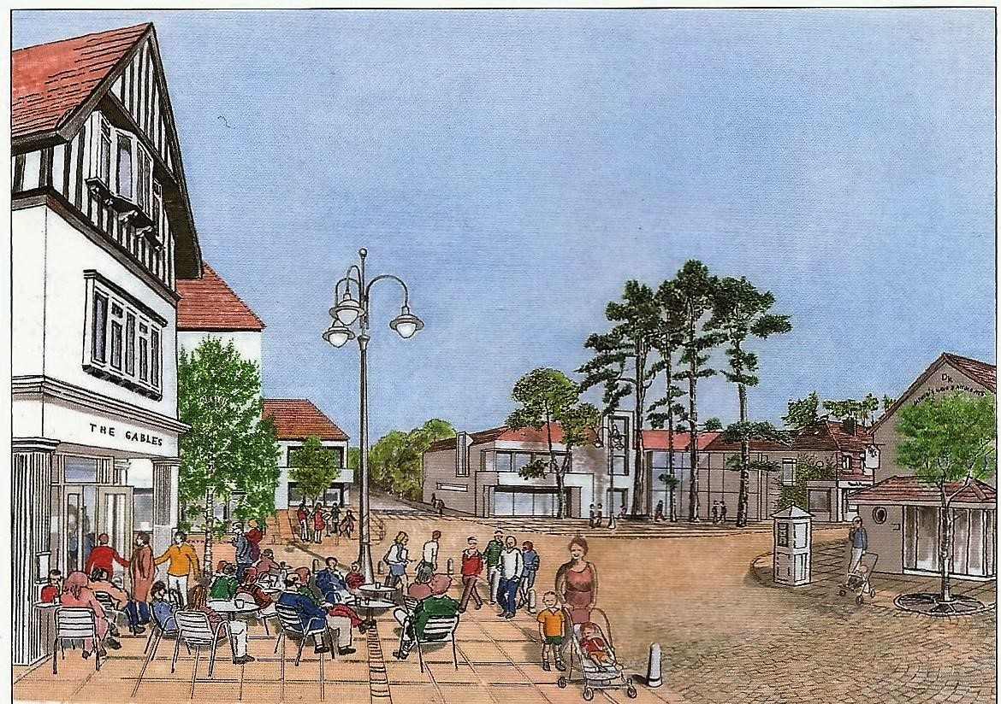

Foxrock Village reimagined (from the Foxrock Village Urban Design Framework)

REFERENCES

- Planning and Development Act 2000: DOEHLG
- Dun Laogaire Rathdown County Development Plans 1998 - 2022
- Foxrock Architectural Conservation Area Character Appraisal: Dun Laogaire Rathdown County Council 2007
- Preliminary Report - Foxrock Village Urban Design Framework: Dun Laogaire Rathdown County Council 2008
- Building Height Strategy: Dun Laogaire Rathdown County Council 2006.
- Residential Density – Guidelines for Planning Authorities.: (DOEHLG 1999)
- Quality Housing for Sustainable Communities Guidelines ( DoEHLG 2007)
- Sustainable Residential Development in Urban Areas - Guidelines for Planning Authorities (DoEHLG 2009)
- Urban Design Manual – A Best Practice Guide (DoEHLG 2009)
- Urban Development and Building Height - Guidelines for Planning Authorities
(Dept. of Housing, Planning and Local Government - December 2018)
- A Platform for Change – Strategy 2000-2016: DTO (2001)
- Foxrock Estate – Brendan Reynolds (Foxrock Local History Club) • Foxrock Miscellany (Foxrock Local History Club)

